
The following details provide a technical overview of the solution as described in the Webzen article titled Gaming Company Gets Projects Back on Track.
Webzen, of Seoul, Korea, is a global digital entertainment leader and developer of Korea’s first 3-D online game, MU Online.
TECHNICAL SOLUTION DETAILS
Solution Overview:
Webzen installed Microsoft® Office Project Server 2007, with Microsoft SQL Server™ 2005 as the project database. The company also deployed Microsoft Office Project Professional 2007 on 300 developers’ and project managers’ desktop computers, to manage daily project tasks. Project data is protected by an internal firewall and Forms Authentication technology in the Windows® operating system.
IT Benefits:
- Lower hardware and software costs from reduced hiring
- Lower IT support costs
- More accurate budgeting
Employee Count:  600 | PC Count:  700 |  | Server Count:  2
Product and Technology List:  - Windows XP  - 2007 Microsoft Office system  - Microsoft Office Project Server 2007  - Microsoft Office Project Professional 2007 |  | - Microsoft Server Product Portfolio  - Windows Server® 2003 Enterprise Edition  - Microsoft Office SharePoint® Server 2007  - Microsoft SQL Server 2005
Hardware Details (if applicable):
Webzen has one server computer running Microsoft Office Project Server 2007 and one running Microsoft SQL Server 2005. Both run the Windows Server® 2003 Enterprise Edition operating system. Webzen’s desktop computers run the Windows® XP operating system.
Workload Details:
Approximately 300 users access Microsoft Office Project Server 2007 daily, with approximately 60 concurrent users.


Neo Plus is a leading technology consultancy and Microsoft Certified Partner in Korea. For more information, visit www.neoplus.co.kr or call +82-2-2082-0500.

System Infrastructure Diagram:
Put partner description here (and adjust bottom of text box if necessary). Style = Sidebar Text. Include URL and contact phone number.
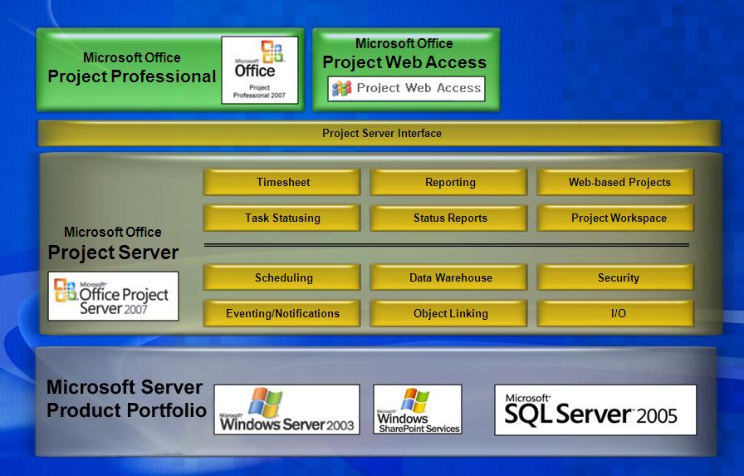

This document is for informational purposes only. MICROSOFT MAKES NO WARRANTIES, EXPRESS OR IMPLIED, IN THIS SUMMARY.
Document published April 2007

